**Scenario:**

* Bob, driving down main street in his patrol car notices smoke coming out of a warehouse. His partner, Alice, reports the emergency from her car.
* Alice enters the address of the building into her wearable computer, a brief description of its location (i.e., north west corner), and an emergency level.
* She confirms her input and waits for an acknowledgment;
* John, the dispatcher, is alerted to the emergency by a beep of his workstation. He reviews the information submitted by Alice and acknowledges the report. He allocates a fire unit and sends the estimated arrival time (ETA) to Alice.
* Alice received the acknowledgment and the ETA.

1. Find all the use cases in the scenario
2. Describe the use cases in more details
   1. Participating actors
   2. Describe entry conditions
   3. Describes the flow of events
   4. Describes exception
   5. Describe nonfunctional requirements

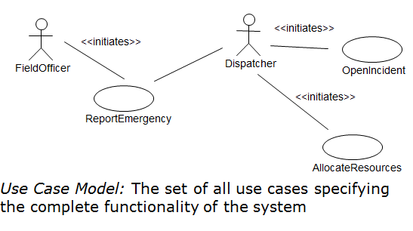

1. **Use case name:** Report Emergency

2. **Participating Actors** : field officer, dispatcher

3**. Entry Condition**: The field officer is logged into the FRIEND System

4. **Flow of Events**:

* 1. The **FieldOfficer** activates the “Report Emergency” function of her terminal. The system responds by presenting a form to the officer.
  2. The FieldOfficer fills the form, by selecting the emergency level, type, location, and brief description of the situation. The FieldOfficer also describes a response to the emergency situation. Once the form is completed, the FieldOfficer submits the form, and the **Dispatcher** is notified.
  3. The Dispatcher creates an Incident in the database by invoking the OpenIncident use case. He selects a response and if notifies the ResourceAllocator of needed resources by invoking the AllocateResources use case. He sends an acknowledgement to the FieldOfficer.
  4. The FieldOfficer receives the acknowledgment and the selected response.

5**. Exit Conditions**: The FieldOfficer has received an acknowledgement and the selected response OR The FieldOfficer has received an explanation indicating why the transaction could not be processed

6. **Exceptions:** The FieldOfficer is notified immediately if the connection between terminal and central is lost

7**. Quality Requirements**: The FieldOfficer’s report is acknowledged within 30 seconds

8**. Glossary:**

* + ***Field Supervisor:*** This is the official at the emergency site
  + ***Resource Allocator:*** The Resource Allocator is responsible for the commitment and release of Resources managed by the FRIEND system
  + ***Dispatcher:*** A Dispatcher enters, updates, and removes Emergency Incidents, Actions, and Requests in the system. The Dispatcher also closes Emergency Incidents
  + ***Field Officer:*** Reports accidents from the Field

1**. Use case name**: AllocateResources

2. **Participating Actors**:Field Officer, Dispatcher, Resource Allocator, Field Supervisor

3. **Entry Condition**:The Dispatcher requests additional resources for an existing Emergency Incident

4**. Flow of Events**:

* 1. The Resource Allocator allocates the needed Resources
  2. The Field Officer on the Emergency Incident is notified of allocated resources
  3. The Resources are committed to the Emergency Incident

5. **Exit Condition:**The use case terminates when the resource is committed . The selected Resource is unavailable to other Requests.

**6. Special Requirements:** The Field Supervisor is responsible for managing Resources.

Use Case: Passenger Purchasing a plane ticket

1. **Use case name:** Purchase ticket

2. **Participating actors**: Passenger

3. **Entry Condition:**

1. Passenger stands in front of ticket distributor

2. Passenger has sufficient money to purchase ticket

4. **Exit Condition:**

1.Passenger has ticket

5: **Flow of Events:**

1. Passenger selects the number of zones to be traveled

2. Ticket Distributor displays the amount due

3. Passenger inserts money, at least the amount due

4. Ticket Distributor returns change

5. Ticket Distributor issues ticket

6**. Special Requirements**: none

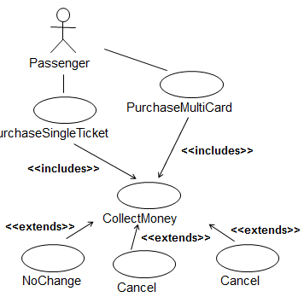

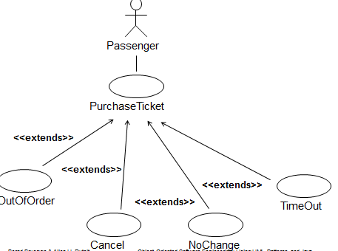

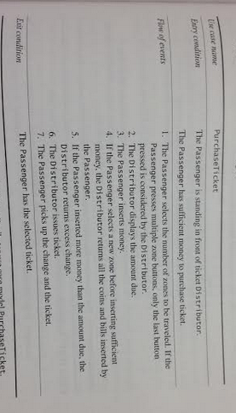Test case:

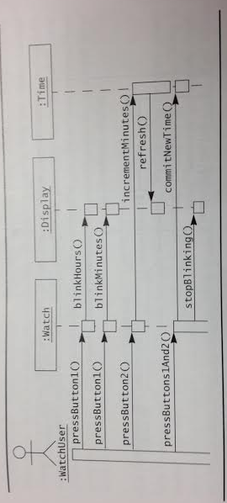Sequence diagram example:

A user presses a button on their watch to display the time. The first press blinks the hours on the display. The second press blinks the minutes on the display. Pressing button 2 while the hours is blinking will increment the hours. If the minutes where blinking instead they would then be incremented. Pressing both button’s will result in the new time being displayed and for the time to stop blinking

**EER Diagram Practice:**

A doctor can be scheduled for many appointments, but may not have any scheduled at all. Each appointment is scheduled with exactly 1 doctor. A patient can schedule 1 or more appointments. One appointment is scheduled with exactly 1 patient. An appointment must generate exactly 1 bill, a bill is generated by only 1 appointment. One payment is applied to exactly 1 bill, and 1 bill can be paid off over time by several payments. A bill can be outstanding, having nothing yet paid on it at all. One patient can make many payments, but a single payment is made by only 1 patient. Some patients are insured by an insurance company. If they are insured, they can only carry insurance with one company. An insurance compnay can have many patients carry their policies. For patients that carry insurance, the insurance company will make payments, each single payment is made by exactly 1 insurance company.

